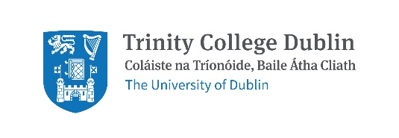

Response to National Transport Authority Greater Dublin Area Transport Strategy 2022–2042 Consultation
Date: 7th January 2022

Summary
The NTA GDA Transport Strategy is a wide-ranging, progressive strategy which Trinity welcomes. We thank the NTA for their work and make a number of comments summarised below.
- Trinity would like this action plan to be implemented as a matter of urgency given the current biodiversity and climate crisis.
- Trinity is frustrated at the delays in big transport projects to date e.g. Metro Link and light rail extensions.
- Trinity has responded to the Strategy with a focus on the four priority routes between our campuses: Trinity Hall to College Green, on Pearse Street, on Nassau Street and from College Green to St. James’s Hospital. Other routes of importance to Trinity include College Green to Santry and College Green to Iveagh Grounds.
- Trinity would like more focus on civic spaces, particularly College Green, and would like biodiversity to be considered in all changes to the built environment.
- The Healthy Ireland Framework is an all of government initiative that sets goals across all departments. Given how important transport is, could a similar approach be taken for this strategy? Trinity is concerned that delivering the strategy will be delayed by lack of political support.
- Trinity is pleased to see the Strategy state that car-centric urban environments have a disproportionately adverse impact on certain groups. Trinity would like children added to the list of groups adversely affected. Trinity would also like wording that states cars will no longer be permitted to dominate the urban environment.
- Trinity is disappointed by the lack of detail on cycling and would like the NTA to consider the recent EU Commission decision which recognises cycling as well as other active modes as a priority for moving people in cities/towns.

General points:
- Engagement: Trinity feels the public is missing from the Plan. Opportunities to reimagine the built environment and be partners in change should be increased. This sort of ongoing capacity building is important for inspiring and sustaining change.
- Editing: While a minor thing, the section numbering in the Executive Summary is different from the section numbering within the main Strategy (e.g. Section 7 in the Executive Strategy is actually Section 8 in the Strategy).
- The consultation process: The consultation platform restricts submissions to chapters. A facility to give general comments is needed.

Chapter 9: Integration and Inclusion
- 9.1 International Gateways: Trinity supports Dublin Port Company plans to create a safe segregated cycle track (Tolka Estuary Greenway) between ferry terminals and East Wall Road, as revealed recently. The construction of a new Point Depot junction with a pedestrian/bicycle bridge (Blood Stoney bridge) near Tom Clarke bridge must happen in conjunction with this project. These are vital parts of a network to allow Trinity commuters access the new Pearse St/Grand Canal Harbour campus.

In a similar manner Trinity seeks a safe segregated route from Dublin Airport to the city centre. Trinity would like to see an initiative like Schiphol Airport’s “You can Bike if you Like”. Schiphol is 16kms from Amsterdam’s Central Station, Dublin Airport is 10kms from Connolly Station and Heuston is 11.6 kms. Amsterdam gets more rain than Dublin. Trinity students and staff would welcome a Bike If You Like equivalent in Dublin Airport.

- 9.16 Enforcement of Road Traffic Laws
The offenses listed should also include: (1) Motorists speeding - speeding in residential zones and 30/50kmph zones is particularly dangerous for other road users and creates a hostile environment for pedestrians and cyclists; (2) Motorists failing to observe a safe distance when passing cyclists; (3) Bicycle theft
"Cyclists travelling on footpaths or pedestrianised streets" should be removed. This typically occurs where there is no cycling infrastructure and/or roads are unsafe and is incomparable with the other offenses listed in terms of severity, threat posed, and frequency of occurrence.
- 9.5 and 9.6: Trinity welcomes the revision of fare structures and next generation ticketing.
- 9.8 Behavioural Change: It is not clear if the definition of behavioural change refers to the NTA’s practice of behaviour change or of behaviour change theory in general. The Ottawa Charter, the founding document for Health Promotion, was created as a method of changing behaviour that incorporates action under five pillars, one of which is “Creating supportive environments.” Promoting behaviour change without building infrastructure to support the behaviour desired, is ineffective. Would the NTA rewrite this paragraph clarifying what definition of behaviour change is referred to and stating that promotion of walking, cycling and public transport will be supported by changes to the environment as mean of achieving success?
- 9.8.1 Smarter Travel Workplaces and Campuses: This programme has been a wholly positive experience for Trinity. Thank you to the NTA for offering it. Trinity has 1% car use because we have so little parking and we are served by almost all public transport, with the exception of segregated cycling. Whilst promotional activities are positive and engaging, our students and staff do not feel safe cycling in Dublin. Trinity would like to see safe segregated cycling on our four priority routes: From Trinity Hall to College Green, on Pearse Street, on Nassau Street and from College Green to St. James’s Hospital.

The draft strategy states: “The outcome of this programme, however, is not measured solely by the numbers of single- occupancy car trips being removed from the roads, but also by the fostering of a sustainable transport culture in places where the car had previously played a predominant role.” Trinity suggests that an external review take place of this programme with particular attention paid to whether, or not, mobility management plans required by grants of planning permission are adhered to.
- 9.11 Accessible Infrastructure
The draft strategy says: “There are many lifts in existing train and tram stations, which are essential for some passengers being able to access a platform or station building. Lifts that break down or are out of service for long periods of time cause a customer to lose confidence in being able to access that station and potentially stop them from using public transport altogether.”

Trinity has some students and staff who are less able from a physical/mental perspective, but our Disability Services unit exists to help them around our campuses. It is vital that they can depend on station lifts working all the time, being able to get on/off DART trains without Irish Rail staff being present, etc.

- 9.14 Equality and Inclusivity Programme: Trinity welcomes this initiative and would like to see infrastructure that supports equality and inclusivity too e.g. disability bike parking, safe segregated cycling.
- Maintenance is a significant barrier to integration and inclusion (e.g. elevators at DART stations) and it notes significant monies have been allocated, but it could be called out as a key opportunity within the Strategy and also within evaluation too. There is no accountability for inaccessibility and that seems odd.
- 9.15 Equality and Impact Assessment: Trinity welcomes this Assessment and would ask that socio-economic status be included too. For many people, private cars are not affordable. The AA estimates that obtaining a driving licence costs approx. €600 and running a car is estimated to cost thousands per annum. Private cars are therefore very exclusive and many of Trinity’s students can’t afford to drive one. Trinity believes it is unfair to allocate so much road space to private cars. We would like space reallocated to walking, cycling and public transport, in particular on our four priority routes: From Trinity Hall to College Green, on Pearse Street, on Nassau Street and from College Green to St. James’s Hospital.
- 9.16 Enforcement of Traffic Laws: Trinity is delighted to see plans to enforce traffic laws and strongly supports NTA actions to do so. Trinity would like to see new laws that limit the size of vehicles on our roads. Trinity would like to explore the idea of cars being issued with emissions stickers that indicate the size of the engine and the quantity of pollution each car emits. Research by Irish Doctor’s for the Environment, presented at a recent Oireachtas Committee highlights the many dangers of cars and the benefits of physical activity.
Trinity notes that France has just introduced a law requiring car ads to promote alternative modes of transport. See here. https://www.npr.org/2022/01/04/1070297325/france-car-ads-climate?t=1641388212140 Trinity would like this strategy to propose the same.

Trinity would like to see markedly improved traffic law enforcement on the routes to and from its campuses for those walking or on bicycles. Far too many bus lanes, cycle tracks and pavements are blocked by motor vehicles during their period of operation. We note that there are few if any traffic wardens still employed.

Background
About Trinity: Trinity is the largest trip attractor in Dublin City Centre. The majority of our 16,000 students and 4,000 staff, study or work on our College Green Campus. Whilst the central work of the university is education and research, Trinity also has 661 on campus student beds on College Green/Pearse Street, approximately 1 million visitors per year to the Book of Kells exhibition and multiple cafes and gift shops open to the public. Our conference, private dining and banqueting services are busy year-round and from mid-May to mid-August we operate as the largest accommodation provider in Dublin with over 1,500 beds a night across our College Green and Trinity Hall campuses.
Trinity’s partnership with the NTA: Trinity has partnered with the National Transport Authority as a Smarter Travel Campus since 2011. Through that partnership, data capture with the National Transport Authority has identified Trinity as a global leader in sustainable transport use with only 1% of our students and staff commuting by private car. Trinity has participated in the National Transport Authority’s annual walking and cycling challenges with participation of greater than 100 people every year. In 2019, Trinity participated in the National Transport Authority’s Smarter Travel awards with one group of our students and one of our lecturers winning an award. Partnering with the National Transport Authority on the Smarter Travel Campus initiative has been a very positive and enjoyable experience and we look forward to continuing to do so.
How Trinity is supporting #LiveableDublin: In 2019, Trinity, PPI Ignite (a research project in Trinity) and BYCS Amsterdam (a Dutch not for profit organisation that promotes cycling) worked with the support of Dublin City Council to facilitate a city-wide debate on how Dublin can become more liveable. During the LiveableDublin events, participants defined and explored the question, “How can we speed up change in Dublin to make it more liveable?”. Trinity made a submission to Dublin City Council on travel during COVID-19 restrictions calling for wider footpaths and safer cycling. We were ranked as the top ‘Green’ University in 2020. Trinity believes this work demonstrates that we are committed to working for and with the city to make Dublin more sustainable and liveable. During COP26, Trinity signed this letter urging governments to boost cycling levels. https://cop26cycling.com/
How people travelled to Trinity pre COVID-19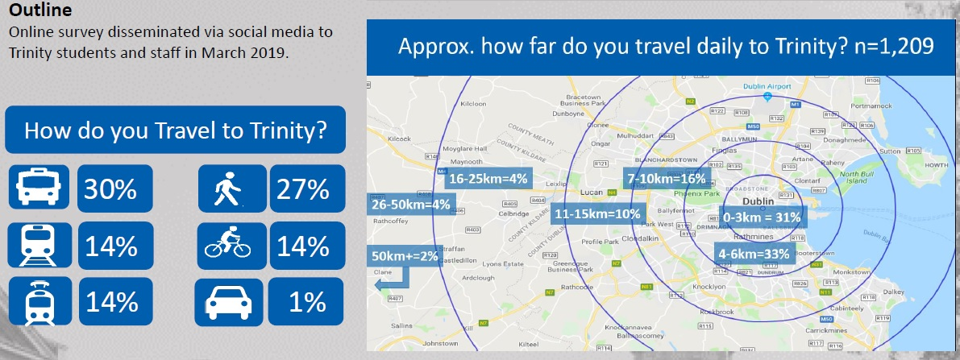
Figure 1. Shows how Trinity students and staff travelled to campus in March 2019
Trinity is a global leader in sustainable transport use. We are lucky, due to our location, to be served by all forms of public transport except safe, segregated cycling.
Completing this document: Trinity notes the primary ongoing and to be completed transport projects for the GDA:
- On-going roll out of cycle tracks and greenways
- Metrolink and DART+ Programme; and
- Investment in bus priority and bus service improvements – BusConnects
- Proposed Luas extensions
We thank the NTA for their progress on these schemes and welcome this review of the Greater Dublin Area Transport Strategy.

Contact Details
For questions/comments on this submission please contact:
Martina Mullin  Health Promotion Officer and Co-Chair of the Healthy Trinity Initiative | Dr Michael McKillen  Adjunct Assistant Professor,  School of Biochemistry & Immunology,
Sarah Bowman  Director of Strategic Engagement | Prof. Clare Kelly  School of Psychology
Clodagh Colleran
Administrative Officer
School of Medicine

https://www.tcd.ie/corporate-services/assets/pdf/annual-report-2018-2019.pdf
https://www.tcd.ie/healthytrinity/travel/Stats.php
https://www.tcd.ie/healthytrinity/liveabledublin/
https://www.tcd.ie/healthytrinity/assets/documents/Covid-19/TCD%20DCC%20Covid%2019%20Submission%20Final.pdf
https://www.tcd.ie/news_events/articles/trinity-wins-best-green-campus-award-2020/

