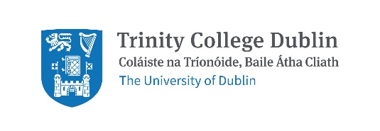

Response to National Transport Authority Greater Dublin Area Transport Strategy 2022–2042 Consultation
Date: 7th January 2022

Summary
The NTA GDA Transport Strategy is a wide-ranging, progressive strategy which Trinity welcomes. We thank the NTA for their work and make a number of comments summarised below.
- Trinity would like this action plan to be implemented as a matter of urgency given the current biodiversity and climate crisis.
- Trinity is frustrated at the delays in big transport projects to date e.g. Metro Link and light rail extensions.
- Trinity has responded to the Strategy with a focus on the four priority routes between our campuses: Trinity Hall to College Green, on Pearse Street, on Nassau Street and from College Green to St. James’s Hospital. Other routes of importance to Trinity include College Green to Santry and College Green to Iveagh Grounds.
- Trinity would like more focus on civic spaces, particularly College Green, and would like biodiversity to be considered in all changes to the built environment.
- The Healthy Ireland Framework is an all of government initiative that sets goals across all departments. Given how important transport is, could a similar approach be taken for this strategy? Trinity is concerned that delivering the strategy will be delayed by lack of political support.
- Trinity is pleased to see the Strategy state that car-centric urban environments have a disproportionately adverse impact on certain groups. Trinity would like children added to the list of groups adversely affected. Trinity would also like wording that states cars will no longer be permitted to dominate the urban environment.
- Trinity is disappointed by the lack of detail on cycling and would like the NTA to consider the recent EU Commission decision which recognises cycling as well as other active modes as a priority for moving people in cities/towns.

General points:
- Editing: While a minor thing, the section numbering in the Executive Summary is different from the section numbering within the main Strategy (e.g. Section 7 in the Executive Strategy is actually Section 8 in the Strategy).
- The consultation process: The consultation platform restricts submissions to chapters. A facility to give general comments is needed.

Background
About Trinity: Trinity is the largest trip attractor in Dublin City Centre. The majority of our 16,000 students and 4,000 staff, study or work on our College Green Campus. Whilst the central work of the university is education and research, Trinity also has 661 on campus student beds on College Green/Pearse Street, approximately 1 million visitors per year to the Book of Kells exhibition and multiple cafes and gift shops open to the public. Our conference, private dining and banqueting services are busy year-round and from mid-May to mid-August we operate as the largest accommodation provider in Dublin with over 1,500 beds a night across our College Green and Trinity Hall campuses.
Trinity’s partnership with the NTA: Trinity has partnered with the National Transport Authority as a Smarter Travel Campus since 2011. Through that partnership, data capture with the National Transport Authority has identified Trinity as a global leader in sustainable transport use with only 1% of our students and staff commuting by private car. Trinity has participated in the National Transport Authority’s annual walking and cycling challenges with participation of greater than 100 people every year. In 2019, Trinity participated in the National Transport Authority’s Smarter Travel awards with one group of our students and one of our lecturers winning an award. Partnering with the National Transport Authority on the Smarter Travel Campus initiative has been a very positive and enjoyable experience and we look forward to continuing to do so.
How Trinity is supporting #LiveableDublin: In 2019, Trinity, PPI Ignite (a research project in Trinity) and BYCS Amsterdam (a Dutch not for profit organisation that promotes cycling) worked with the support of Dublin City Council to facilitate a city-wide debate on how Dublin can become more liveable. During the LiveableDublin events, participants defined and explored the question, “How can we speed up change in Dublin to make it more liveable?”. Trinity made a submission to Dublin City Council on travel during COVID-19 restrictions calling for wider footpaths and safer cycling. We were ranked as the top ‘Green’ University in 2020. Trinity believes this work demonstrates that we are committed to working for and with the city to make Dublin more sustainable and liveable. During COP26, Trinity signed this letter urging governments to boost cycling levels. https://cop26cycling.com/
How people travelled to Trinity pre COVID-19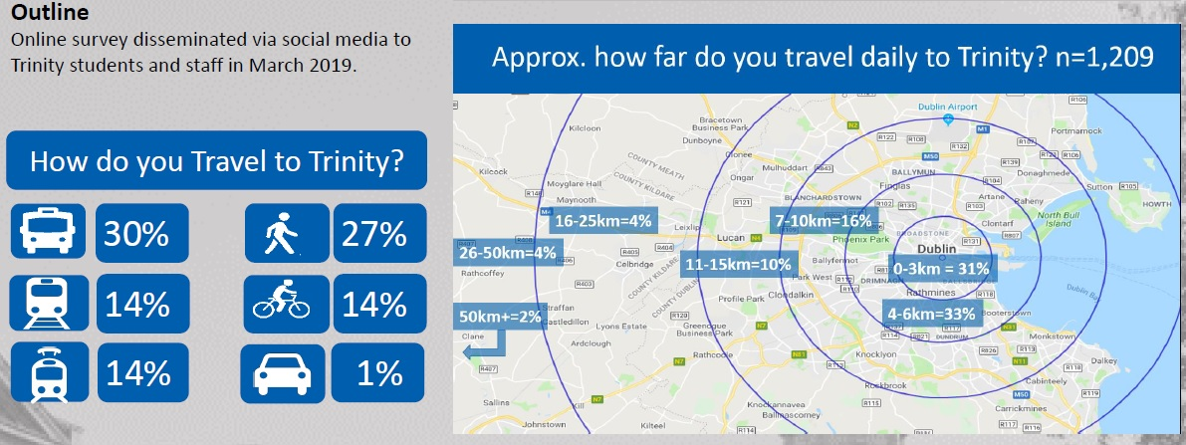
Figure 1. Shows how Trinity students and staff travelled to campus in March 2019
Trinity is a global leader in sustainable transport use. We are lucky, due to our location, to be served by all forms of public transport except safe, segregated cycling.
Completing this document: Trinity notes the primary ongoing and to be completed transport projects for the GDA:
- On-going roll out of cycle tracks and greenways
- Metrolink and DART+ Programme; and
- Investment in bus priority and bus service improvements – BusConnects
- Proposed Luas extensions
We thank the NTA for their progress on these schemes and welcome this review of the Greater Dublin Area Transport Strategy.

Contact Details
For questions/comments on this submission please contact:
Martina Mullin  Health Promotion Officer and Co-Chair of the Healthy Trinity Initiative | Dr Michael McKillen  Adjunct Assistant Professor,  School of Biochemistry & Immunology,
Sarah Bowman  Director of Strategic Engagement | Prof. Clare Kelly  School of Psychology
Clodagh Colleran
Administrative Officer
School of Medicine

https://www.tcd.ie/corporate-services/assets/pdf/annual-report-2018-2019.pdf
https://www.tcd.ie/healthytrinity/travel/Stats.php
https://www.tcd.ie/healthytrinity/liveabledublin/
https://www.tcd.ie/healthytrinity/assets/documents/Covid-19/TCD%20DCC%20Covid%2019%20Submission%20Final.pdf
https://www.tcd.ie/news_events/articles/trinity-wins-best-green-campus-award-2020/

