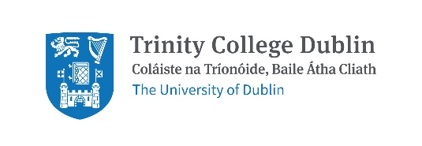

Response to National Transport Authority Greater Dublin Area Transport Strategy 2022–2042 Consultation
Date: 7th January 2022

Summary
The NTA GDA Transport Strategy is a wide-ranging, progressive strategy which Trinity welcomes. We thank the NTA for their work and make a number of comments summarised below.
- Trinity would like this action plan to be implemented as a matter of urgency given the current biodiversity and climate crisis.
- Trinity is frustrated at the delays in big transport projects to date e.g. Metro Link and light rail extensions.
- Trinity has responded to the Strategy with a focus on the four priority routes between our campuses: Trinity Hall to College Green, on Pearse Street, on Nassau Street and from College Green to St. James’s Hospital. Other routes of importance to Trinity include College Green to Santry and College Green to Iveagh Grounds.
- Trinity would like more focus on civic spaces, particularly College Green, and would like biodiversity to be considered in all changes to the built environment.
- The Healthy Ireland Framework is an all of government initiative that sets goals across all departments. Given how important transport is, could a similar approach be taken for this strategy? Trinity is concerned that delivering the strategy will be delayed by lack of political support.
- Trinity is pleased to see the Strategy state that car-centric urban environments have a disproportionately adverse impact on certain groups. Trinity would like children added to the list of groups adversely affected. Trinity would also like wording that states cars will no longer be permitted to dominate the urban environment.
- Trinity is disappointed by the lack of detail on cycling and would like the NTA to consider the recent EU Commission decision which recognises cycling as well as other active modes as a priority for moving people in cities/towns.

General points:
- Engagement: Trinity feels the public is missing from the Plan. Opportunities to reimagine the built environment and be partners in change should be increased. This sort of ongoing capacity building is important for inspiring and sustaining change.
- Editing: While a minor thing, the section numbering in the Executive Summary is different from the section numbering within the main Strategy (e.g. Section 7 in the Executive Strategy is actually Section 8 in the Strategy).
- The consultation process: The consultation platform restricts submissions to chapters. A facility to give general comments is needed.

Trinity’s Feedback on the Strategy

Chapter 14: Traffic Management and Travel Options
Trinity welcomes measures to reduce parking including public sector parking in Dublin City Centre.
Variable Speed Zones could include Safe Routes to School Zones and peak school times too.
- Page 174+. Parking Standards: In addition to the number of spaces, the placement of parking in front of homes wastes huge amounts of space in most developments, which could provide housing options and rental income. There appears to be no encouragement of the use of alleys or rear parking to encourage the construction of small homes / accessible accessory dwelling units or larger gardens for those who don’t want/need parking, while managing refuse collection more effectively. Parking maximums rather than parking minimums is the right way to go. Where is the focus on bicycle parking though?
- 14.11.1 Car Free Residential Developments: states: “In providing for car-free developments, the two key considerations will be the level of mobility that can be offered to future residents by the transport network in terms of public transport and the provision of high-quality cycle infrastructure, and the potential for adverse effects of overspill parking on neighbouring residential roads and streets.” Provision of high quality cycle infrastructure and bicycle parking are symbiotic. Not everyone can store their bicycle at their home and older residential developments may not have lifts or underground bicycle parking. This section needs to name bicycle parking as the third consideration or state that ‘high-quality cycle infrastructure’ includes bicycle parking. Of note, there is a heading titled Residential Car Parking Standards (14.11.2) and a Table (15.1) setting out maximum parking provision. There no heading on Residential Bicycle Parking or the equivalent Table or Targets. Residential Bicycle Parking and the equivalent Table and Targets should also be considered for inclusion.
- The draft strategy states: “Every mode of travel needs to be accommodated in some form in order to ensure that the needs of residents, businesses, workers and visitors are met. These needs, however, must be balanced in a way that favours sustainable mobility and the transition to a zero-carbon transport system, and the level of accommodation of each mode will not be equal on every road and street.”

Provision for safe/segregated cycling infrastructure is Trinity’s priority. We have very high cycling mode share.

Again Trinity would like to emphasise the importance of College Green to our university and the approaches to it – Dame St/Pearse St. Nassau Street and other routes.

- 14.4 Reduced Speed Limits: Trinity strongly supports 30 km/h speed limits in Dublin and particular on Pearse Street which is very hostile to walking and cycling.

Background
About Trinity: Trinity is the largest trip attractor in Dublin City Centre. The majority of our 16,000 students and 4,000 staff, study or work on our College Green Campus. Whilst the central work of the university is education and research, Trinity also has 661 on campus student beds on College Green/Pearse Street, approximately 1 million visitors per year to the Book of Kells exhibition and multiple cafes and gift shops open to the public. Our conference, private dining and banqueting services are busy year-round and from mid-May to mid-August we operate as the largest accommodation provider in Dublin with over 1,500 beds a night across our College Green and Trinity Hall campuses.
Trinity’s partnership with the NTA: Trinity has partnered with the National Transport Authority as a Smarter Travel Campus since 2011. Through that partnership, data capture with the National Transport Authority has identified Trinity as a global leader in sustainable transport use with only 1% of our students and staff commuting by private car. Trinity has participated in the National Transport Authority’s annual walking and cycling challenges with participation of greater than 100 people every year. In 2019, Trinity participated in the National Transport Authority’s Smarter Travel awards with one group of our students and one of our lecturers winning an award. Partnering with the National Transport Authority on the Smarter Travel Campus initiative has been a very positive and enjoyable experience and we look forward to continuing to do so.
How Trinity is supporting #LiveableDublin: In 2019, Trinity, PPI Ignite (a research project in Trinity) and BYCS Amsterdam (a Dutch not for profit organisation that promotes cycling) worked with the support of Dublin City Council to facilitate a city-wide debate on how Dublin can become more liveable. During the LiveableDublin events, participants defined and explored the question, “How can we speed up change in Dublin to make it more liveable?”. Trinity made a submission to Dublin City Council on travel during COVID-19 restrictions calling for wider footpaths and safer cycling. We were ranked as the top ‘Green’ University in 2020. Trinity believes this work demonstrates that we are committed to working for and with the city to make Dublin more sustainable and liveable. During COP26, Trinity signed this letter urging governments to boost cycling levels. https://cop26cycling.com/
How people travelled to Trinity pre COVID-19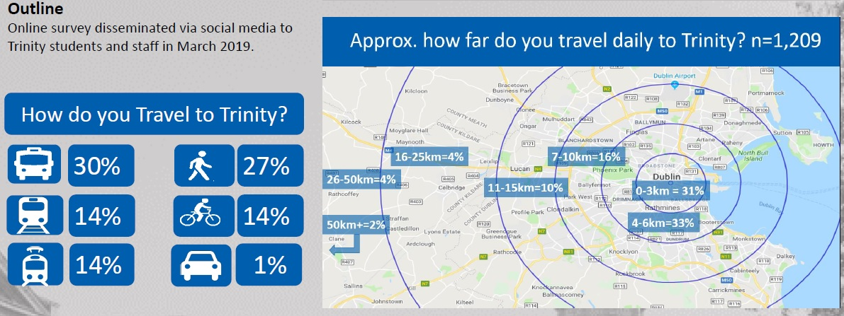
Figure 1. Shows how Trinity students and staff travelled to campus in March 2019
Trinity is a global leader in sustainable transport use. We are lucky, due to our location, to be served by all forms of public transport except safe, segregated cycling.
Completing this document: Trinity notes the primary ongoing and to be completed transport projects for the GDA:
- On-going roll out of cycle tracks and greenways
- Metrolink and DART+ Programme; and
- Investment in bus priority and bus service improvements – BusConnects
- Proposed Luas extensions
We thank the NTA for their progress on these schemes and welcome this review of the Greater Dublin Area Transport Strategy.

Contact Details
For questions/comments on this submission please contact:
Martina Mullin  Health Promotion Officer and Co-Chair of the Healthy Trinity Initiative | Dr Michael McKillen  Adjunct Assistant Professor,  School of Biochemistry & Immunology,
Sarah Bowman  Director of Strategic Engagement | Prof. Clare Kelly  School of Psychology
Clodagh Colleran
Administrative Officer
School of Medicine

https://www.tcd.ie/corporate-services/assets/pdf/annual-report-2018-2019.pdf
https://www.tcd.ie/healthytrinity/travel/Stats.php
https://www.tcd.ie/healthytrinity/liveabledublin/
https://www.tcd.ie/healthytrinity/assets/documents/Covid-19/TCD%20DCC%20Covid%2019%20Submission%20Final.pdf
https://www.tcd.ie/news_events/articles/trinity-wins-best-green-campus-award-2020/

