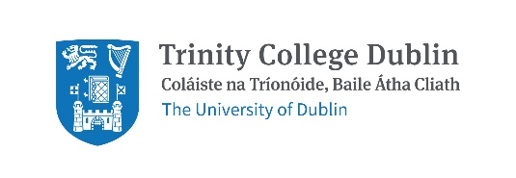

Response to National Transport Authority Greater Dublin Area Transport Strategy 2022–2042 Consultation
Date: 7th January 2022

Summary
The NTA GDA Transport Strategy is a wide-ranging, progressive strategy which Trinity welcomes. We thank the NTA for their work and make a number of comments summarised below.
- Trinity would like this action plan to be implemented as a matter of urgency given the current biodiversity and climate crisis.
- Trinity is frustrated at the delays in big transport projects to date e.g. Metro Link and light rail extensions.
- Trinity has responded to the Strategy with a focus on the four priority routes between our campuses: Trinity Hall to College Green, on Pearse Street, on Nassau Street and from College Green to St. James’s Hospital. Other routes of importance to Trinity include College Green to Santry and College Green to Iveagh Grounds.
- Trinity would like more focus on civic spaces, particularly College Green, and would like biodiversity to be considered in all changes to the built environment.
- The Healthy Ireland Framework is an all of government initiative that sets goals across all departments. Given how important transport is, could a similar approach be taken for this strategy? Trinity is concerned that delivering the strategy will be delayed by lack of political support.
- Trinity is pleased to see the Strategy state that car-centric urban environments have a disproportionately adverse impact on certain groups. Trinity would like children added to the list of groups adversely affected. Trinity would also like wording that states cars will no longer be permitted to dominate the urban environment.
- Trinity is disappointed by the lack of detail on cycling and would like the NTA to consider the recent EU Commission decision which recognises cycling as well as other active modes as a priority for moving people in cities/towns.

General points:
- Engagement: Trinity feels the public is missing from the Plan. Opportunities to reimagine the built environment and be partners in change should be increased. This sort of ongoing capacity building is important for inspiring and sustaining change.
- Editing: While a minor thing, the section numbering in the Executive Summary is different from the section numbering within the main Strategy (e.g. Section 7 in the Executive Strategy is actually Section 8 in the Strategy).
- The consultation process: The consultation platform restricts submissions to chapters. A facility to give general comments is needed.

Trinity’s Feedback on the Strategy

Chapter 11: Cycling and Personal Mobility Devices
This section says nothing about a commitment specifically to safe, fully segregated, fully connected cycling infrastructure, despite highlighting the fact that the overwhelming majority want this and say it would help them to cycle more!
“69% would find more cycle tracks along roads, physically separated from traffic and pedestrians useful to help them cycle more."
“84% of residents also support building more physically separated on-road cycle tracks, even when this would mean less space for other road traffic."
Throughout this section, "Cycle Network" is entirely vague - especially since it is considered to be in existence already. This section should spell out what a cycling network is. Overall, a disappointing section - to achieve aims of 51% reduction in GHG emissions, cycling should be prioritised in this strategy
This recent EU Commission decision under its Urban Mobility Framework (UMF) recognises the primary role of cycling and other forms of active transport in moving people in cities/towns. https://ecf.com/news-and-events/news/ecf-analysis-new-european-urban-mobility-framework-major-win-cycling. Trinity would like to see this decision incorporated into the Greater Dublin Area Transport Strategy.
The ECF states in its response to UMF (22 Dec 2021): We also applaud the Commission’s emphasis on mobility as “a critical aspect of social inclusion and an important determinant of human well-being, especially for disadvantaged groups,” and that transport is “an essential service in the European Pillar of Social Rights.”
Trinity would like the protection of COVID19 measures – Nassau Street contraflow cycle track, etc. Trinity is concerned by the statement ““It is inevitable that not all temporary measures will be retained via the formal planning process but the change in mentality as to what is possible for cycling must be harnessed and built upon over the coming years to deliver the step-change in facilities that is being demanded”. While there has been a number of high quality schemes delivered across the region, such as along sections of the canals and on some key radial routes, the requirement to deliver a coherent network linking origins and destinations and catering for trips within communities and to schools remains. The need to deliver this comprehensive network has become even more apparent during the Covid-19 pandemic.
This is a crucial issue. There is no safe, segregated and comfortable cycling route between the main campus and any of the other Trinity campuses.
Holding onto what we gained under COVID19 emergency measures is vital – The Nassau St. contraflow, for example.
- 11.3 GDA Cycle Network: Figure 11.1 - Where is this? What do the different coloured roads correspond to here? Legend/key needed.
- Measure CYC1 – GDA Cycle Network: "It is the intention of the NTA and the local authorities to deliver a safe, comprehensive, fully connected, attractive and legible cycle network in accordance with the updated Greater Dublin Area Cycle Network.

The "network" such as it can be said to exist is completely piecemeal and disconnected. Any network must be fully connected. This needs to be built into the design. Cycling any distance in Dublin can only be done by expert road users - certainly not children, the elderly, or anyone with accessibility needs.

The draft strategy states: “It is the intention of the NTA and the local authorities to deliver a safe, comprehensive, attractive and legible cycle network in accordance with the updated Greater Dublin Area Cycle Network”. Trinity would like to see a timeframe for the different elements of this network and a funding stream clearly set out.

- Measure CYC2 – Cycle Infrastructure Design: "It is the intention of the NTA to ensure that cycle infrastructure in the GDA provides an appropriate quality of service to all users, through the implementation of the design guidance contained in the latest version of the National Cycle Manual." The National Cycle Manual contains guidelines that are out of step with international best practice, resulting in unsafe infrastructure being implemented - which is counterproductive and an enormous waste of money.

In revising the manual, the NTA must attend to the best international examples of cycle design, including: https://www.sustrans.org.uk/for-professionals/infrastructure/walking-and-cycling-infrastructure-design-guidance https://dutchcycling.nl/en/news/blog/5-design-principles-for-successful-bicycle-infrastructure

- 11.4 Cycle infrastructure design: Trinity welcomes the focus on gender but is disappointed by the lack of specific details on cycle infrastructure design. The document refers to personal security concerns on green ways but does not refer to personal safety concerns while commuting, a concern regularly raised by women and men in Trinity. Trinity asks the NTA to focus on making commuting by bike safe for all as a matter of urgency.

Trinity asks the NTA to review and respond to our cycling injury research, link here which found that, “side to side impacts, impacts between the front of the cyclist/bicycle and the side of the vehicle, and impacts with open(ing) doors emerge as important impact configurations with the inclusion of self-reported cases. For single cyclist collisions, the importance of loss of traction of the tyres due to slippery road conditions and interactions with tram tracks and kerbs are emphasised.”

Trinity would like to see rail groove composite inserts at Luas track crossing-points to make it safer for cyclists to cross the tracks - at College Green, in particular

There are opportunities to identify safe, secure, and sheltered bicycle parking within the Strategy. It appears missing throughout.

Trinity notes that the Netherlands has installed a rainbow cycle lane. https://nltimes.nl/2021/06/09/video-utrecht-get-worlds-longest-rainbow-bike-path Could Dublin have similar?

Page 97: Why is 12% the projected total mode share for bicycles by 2042? It would be useful to hear from researchers on the appropriateness of this figure and how it is presented. Should there be targeted areas for mode shift (e.g. increased % tied to equity or equality elements) rather than the general number for across Dublin? Is the figure appropriate or too conservative?

Trinity would like to see a revision of the National Cycle Manual (NCM) in tandem with Design Manual for Urban Roads & Streets (DMURS) & Transport Infrastructure Ireland (TII) design manuals/guidance in relation to provision for cycling. Each guidance manual should be singing-from-same-hymn sheet! Design of cycle tracks must be suitable for the wide range of types of bicycle, e-scooters and mobility-aids in use these days – cargobikes, handcycles, standard bicycles with big boxes on front/rear carriers, etc.

- 11.5 Cycle Parking: A reduction in car dominance and genuine effort to reduce car use requires that cycle parking, along with car parking for individuals with accessibility needs, should be prioritised. This should include parking suitable for all bikes, including cargo.

The section on Car Parking (14.11) includes a section on Car Parking Standards (14.11.2). In the Bicycle Parking section, an equivalent section Cycle Parking Standards needs to be added.

Section 11.8 recognises ebikes as an emerging Personal Mobility Mode and in Section 8.11 for longer trips. In the Cycle Parking Standards section, specific mention needs to be made of bicycle parking for ebikes. As they are an electric device with a battery, much like a laptop or mobile phone, they cannot be left out all day every day in inclement weather and particularly in frost and rain. Providing sheltered facilities for cycle parking; at Park and Ride facilities, at train and Dart stations, Luas and more rural (Enniskerry is a great example of sheltered bike parking beside a bus stop on the edge of the village) bus stops and in urban centres, as part of a designated section on Cycle Parking and encouraging integrated transport choices. (and a commitment to Cycle Parking Standards)

Trinity thanks the NTA for its continuing provision of funds to upgrade and expand its bike parking provision.

- 11.7 Bikes on Public Transport: "As such, all Irish Rail services using newly procured fleet, including new DART fleet, will accommodate a minimum of 4 bicycles per train, in addition to an unlimited number of folding bikes." This is not enough - it should be 4 bicycles per carriage. Again, a lack of ambition.

Trinity would like the NTA to consider front bike racks for buses - as employed in e.g., the Pacific Northwest USA e.g., https://kingcounty.gov/depts/transportation/metro/travel-options/bike/loading-unloading.aspx

The NTA states the Luas is “unsuited for carriage of standard bicycles on board”. Trinity does not agree with the NTA/TII position. We observe bikes carried on on-street tram services in cities across the EU. On those services there are fixings within the car or a storage area at the end of the tram set in which to store bike. Bikes are held in place using Velcro-straps.

- 11.8 Emerging Personal Mobility Modes: Cargo bikes should be included here.

- Bike to College Scheme: Trinity made a commitment in this submission to Dublin City Council to lobby for a Bike to College Scheme. Trinity would like to see a Bike To College scheme for students like the bike to work scheme. Details here.

Background
About Trinity: Trinity is the largest trip attractor in Dublin City Centre. The majority of our 16,000 students and 4,000 staff, study or work on our College Green Campus. Whilst the central work of the university is education and research, Trinity also has 661 on campus student beds on College Green/Pearse Street, approximately 1 million visitors per year to the Book of Kells exhibition and multiple cafes and gift shops open to the public. Our conference, private dining and banqueting services are busy year-round and from mid-May to mid-August we operate as the largest accommodation provider in Dublin with over 1,500 beds a night across our College Green and Trinity Hall campuses.
Trinity’s partnership with the NTA: Trinity has partnered with the National Transport Authority as a Smarter Travel Campus since 2011. Through that partnership, data capture with the National Transport Authority has identified Trinity as a global leader in sustainable transport use with only 1% of our students and staff commuting by private car. Trinity has participated in the National Transport Authority’s annual walking and cycling challenges with participation of greater than 100 people every year. In 2019, Trinity participated in the National Transport Authority’s Smarter Travel awards with one group of our students and one of our lecturers winning an award. Partnering with the National Transport Authority on the Smarter Travel Campus initiative has been a very positive and enjoyable experience and we look forward to continuing to do so.
How Trinity is supporting #LiveableDublin: In 2019, Trinity, PPI Ignite (a research project in Trinity) and BYCS Amsterdam (a Dutch not for profit organisation that promotes cycling) worked with the support of Dublin City Council to facilitate a city-wide debate on how Dublin can become more liveable. During the LiveableDublin events, participants defined and explored the question, “How can we speed up change in Dublin to make it more liveable?”. Trinity made a submission to Dublin City Council on travel during COVID-19 restrictions calling for wider footpaths and safer cycling. We were ranked as the top ‘Green’ University in 2020. Trinity believes this work demonstrates that we are committed to working for and with the city to make Dublin more sustainable and liveable. During COP26, Trinity signed this letter urging governments to boost cycling levels. https://cop26cycling.com/
How people travelled to Trinity pre COVID-19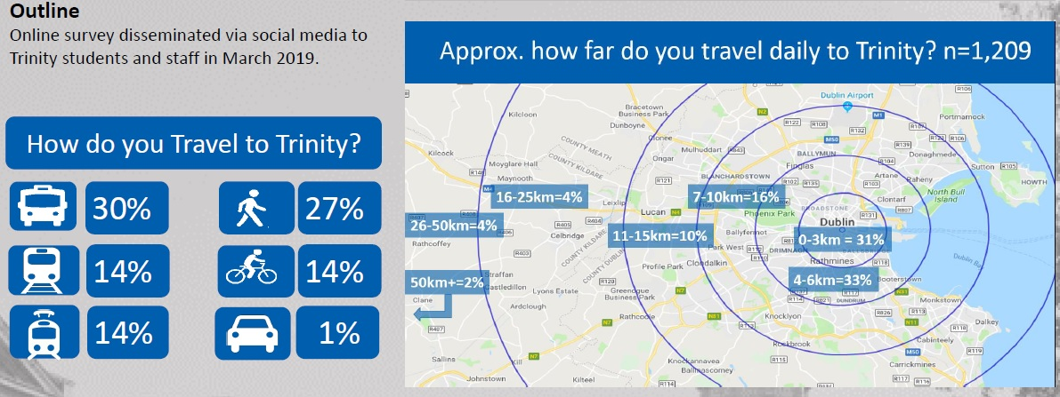
Figure 1. Shows how Trinity students and staff travelled to campus in March 2019
Trinity is a global leader in sustainable transport use. We are lucky, due to our location, to be served by all forms of public transport except safe, segregated cycling.
Completing this document: Trinity notes the primary ongoing and to be completed transport projects for the GDA:
- On-going roll out of cycle tracks and greenways
- Metrolink and DART+ Programme; and
- Investment in bus priority and bus service improvements – BusConnects
- Proposed Luas extensions
We thank the NTA for their progress on these schemes and welcome this review of the Greater Dublin Area Transport Strategy.

Contact Details
For questions/comments on this submission please contact:
Martina Mullin  Health Promotion Officer and Co-Chair of the Healthy Trinity Initiative | Dr Michael McKillen  Adjunct Assistant Professor,  School of Biochemistry & Immunology,
Sarah Bowman  Director of Strategic Engagement | Prof. Clare Kelly  School of Psychology
Clodagh Colleran
Administrative Officer
School of Medicine

https://www.tcd.ie/corporate-services/assets/pdf/annual-report-2018-2019.pdf
https://www.tcd.ie/healthytrinity/travel/Stats.php
https://www.tcd.ie/healthytrinity/liveabledublin/
https://www.tcd.ie/healthytrinity/assets/documents/Covid-19/TCD%20DCC%20Covid%2019%20Submission%20Final.pdf
https://www.tcd.ie/news_events/articles/trinity-wins-best-green-campus-award-2020/

