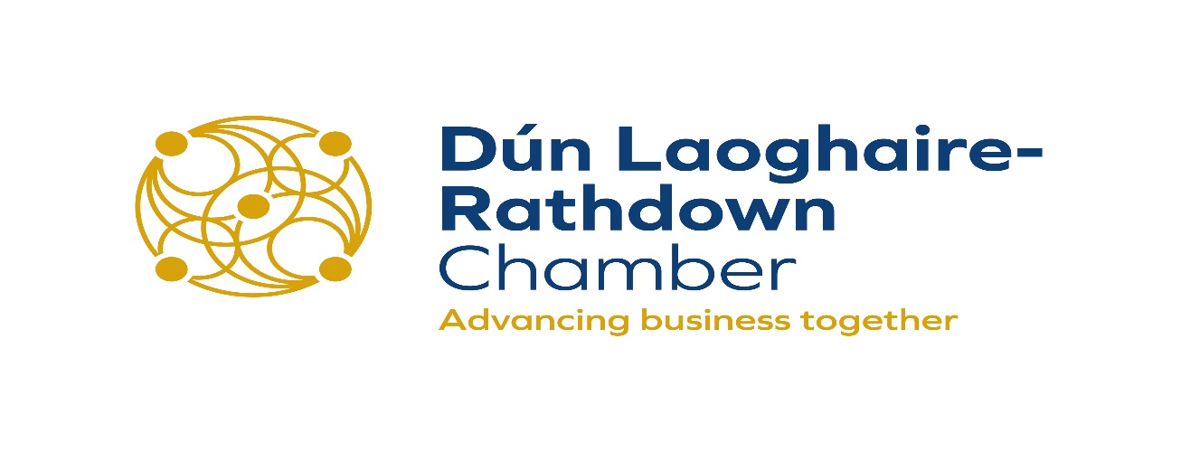

Response from DLR Chamber to the NTA Dublin and Easter REC Draft Greater Dublin Area Transport Strategy 2022-2042

10th January 2022

From: Dún Laoghaire Rathdown Chamber of Commerce
Avoca House, 8 Marine Road, Dún Laoghaire, Co. Dublin. A96 X8Y6

Introduction and context

Dún Laoghaire Rathdown Chamber of Commerce welcomes the opportunity for businesses and community in DLR to input into the Draft Greater Dublin Area Transport Strategy 2022-2042.

Dún Laoghaire Rathdown Chamber of Commerce, celebrating 73 years in 2022, is the largest business network in Dun Laoghaire Rathdown and is the voice of business in the county, offering an environment where business can grow and develop in a dynamic supportive and nurturing community and aims to be the most dynamic, supportive and trustworthy advocate of business on the island of Ireland.

The mission of the Chamber is to promote Dún Laoghaire Rathdown as the premier location for business in Ireland, by influencing key external stakeholders in sharing and implementing this vision. We provide a platform for business to grow and develop by representing and supporting business interests and responding to business needs through submissions to Government (local and national) on issues affecting business; through the provision of events for members to promote their business with the aim of growing and enhancing the economic and social prosperity of Dún Laoghaire Rathdown and Ireland. A good and sustainable transport service – encompassing public and private transport, is key to our vision, as well as yours.

With members in every geographic area and economic sector in Dun Laoghaire Rathdown we are well positioned to understand the concerns of business owners and represent their views. The Chamber is the umbrella body for business interests in Dún Laoghaire Rathdown, representing in excess of 400 businesses of varying sizes from all sectors of industry in Dún Laoghaire Rathdown including key corporate members who are the largest contributors to DLR rate income.

The Chamber is a network that directly serves not only its member businesses but the wider business community. The Chamber represents its members’ interests, encouraging business growth, employment and promoting the development of Dún Laoghaire Rathdown as the premier place to do business in Ireland, as well as an attractive tourist destination. Notwithstanding the recent positive growth in the economy, we recognise the fiscal and resource constraints that both the public and private sectors are operating under.

In relation to The Dublin & Eastern REC’s (draft) submission to the NTA’s public consultation on the Draft Greater Dublin Area
Transport Strategy (2022 – 2042).

The Chamber representing Dún Laoghaire Rathdown business community has studied the Transport Strategy (2022 – 2040) document with great interest.

We welcome the forward planning within this document, and its vision.

There is nothing negative in our thinking and we have great hopes for the future of Dún Laoghaire Rathdown county and for the greater Dublin area.

However we must state that making historical comparisons with transport systems and usage which includes and compares such public transport systems including the LUAS and Dart with UK and EU public transportation systems is difficult for the public transport facilities differ widely.

We further recommend that Dún Laoghaire Rathdown itself, and Tourism must be included as part of this forward planning and thinking.

Our comments in relation to Dún Laoghaire Rathdown relate to the following key points:

1/ The inclusion of Dún Laoghaire Rathdown within this strategy
2/ Bus Connects to include both Coastal and Rural Area routes – taking both local traffic and tourism under consideration
3/ Tourism itself and links to both our Rural and Coastal Areas particularly taking Cruise Tourism into consideration as well as a Ports Strategy
4/ Ebiking/Escooters

2. BusConnects Core Bus Corridors – Dublin Area
1. Clongriffin to City Centre
2. Swords to City Centre
3. Ballymun/Finglas to City Centre
4. Blanchardstown to City Centre
5. Lucan to City to Centre
6. Liffey Valley to City Centre
7. Tallaght/Clondalkin to City Centre
8. Kimmage to City Centre
9. Templeogue/Rathfarnham to City Centre
10. Bray to City Centre
11. Belfield/Blackrock to City Centre
12. Ringsend to City Centre

Bus Connects Corridor in the Dún Laoghaire Rathdown County Council area.

There is little reference to improving the Bus Connects Corridor in the Dún Laoghaire Rathdown County Council area. The stated intention of the BusConnects programme is to increase the capacity and frequency of bus services.

The need to increase and develop the South Dublin City East / West Bus routes, linking Dalkey, Dún Laoghaire, Sandyford, Dundrum, Churchtown, Rathfarnham to Tallaght is of major importance and needs to receive a higher priority.

Furthermore we believe that the rural area of our county has not been considered in this report, either from a local access perspective or from an overall tourism perspective, especially when you consider that the Dublin Mountains are a key outdoor recreation area for both Ireland, and for tourism in general. This is despite submissions from both locals and tourism interests to Bus Connects.

We believe that this must be looked at with urgency.

Metrolink 2031-2042.
The importance of the Metrolink 2031-2042 cannot be overstated for the city of Dublin and the eastern part of Ireland, but again there will be of little direct benefit to the DLR Business community or for those who actually reside or work in this county, unless we have smooth links to our airports and ports from all parts of our county.

3/ Tourism – Coastal and Rural

We believe that a Tourism strategy must be part of the Greater Dublin Area Transport Strategy 2022-42.

As hospitality was hit badly, and continues to suffer as a result of the Pandemic, we believe that tourism needs must be addressed very clearly within this transport strategy, to include Dún Laoghaire Rathdown, as a county, where we have a huge coastal tourism offering, as well as tourism in the Dublin Mountains.

Dublin Port and Dún Laoghaire Port Facilities: the need to introduce a combined strategy, thereby lining operations, where Dún Laoghaire Port would support business transportation processes.

As stated, to support Dublin Port in scaling to full capacity by 2040, the GDA Transport Strategy must allow for the development of a Southern Port Access Route (SPAR) as a private road for port-related HGV traffic by Dublin Port itself. The construction of the SPAR is time critical. This debate must address the following “is the Business and Tourism Services currently being delivered through Dublin Port going to remain a viable project.

Is there an business opportunity or a social need to develop Dún Laoghaire Port to match the creation of a new Dublin Port infrastructure, which is expected to be completed 2040.

Our concern here is recently stated objectives of Dublin Port Authority to limit/stop the Cruise Ships coming to Dublin.

And as Dún Laoghaire Port already has a plethora of Cruise Ships coming in 2022 alone, there must be a strategy, from a tourism perspective, along our coastline, to integrate this into your strategy.

Rail Freight Strategy 2040
The ten-year strategy for the road haulage sector could benefit more if a strategy linking Dún Laoghaire Port Ferries with the Irish National Freight and Passenger train services was developed.
Such linking would benefit Ireland’s business and be of particular interest to Dún Laoghaire Business fraternity.

Rural Transport Strategy – with a particular focus on the Dublin Mountains
The areas at the foothills of the Dublin Mountains are ear-marked for huge development within the next 10 years.

And as the Dublin Mountains are the “lungs of Greater Dublin” there should be inclusion of a strategy for both tourism as well as locals to have improved public transport access to the Dublin Mountains as well as the Coast.

DLR ‘s slogan is from The Mountains to the Sea – and this must feature in the strategy up to 2040.

4. Ebiking/Escooters

Linking Cycling and Personal Mobility Devices.

Evaluating a plan for the future will have to include information pertaining to the safe use and management of Bicycle Parking including parking for Electric Bicycles and Electric Scooter facilities, including safe charging and secure areas, near Bus intersections, Train, Dart and LUAS Stations. While the legal debate re the use of Electric Scooters is on-going.
Having regard to the actual financial costs of purchasing Bicycles, including Electric Bicycles and Electric |Scooters while thinking of evolving futuristic social constructive controls processes.

This should also include the provision of Battery Swop Stations, as well as Battery Charging areas.

And one area of concern
It must be remembered that in December 2021, London Transportation prohibited the carriage of Electric Bicycles and Electric Scooters on board London Transportation facilities.

This prohibition results from the increasing number of Lithium Battery Fires which have occurred and is related to the Fire Brigades difficulty in putting out those Lithium Battery fires. These fire hazards must be looked at, when developing these strategies.

The CEO, President and Board of DLR Chamber

Dún Laoghaire Rathdown Chamber of Commerce
January 2022
www.dlchamber.ie

Corporate Members
